Empty Homes Deep Dive – Washington
held on Tuesday 27 August 2024 – 9:00am – 15:00pm
at Washington Board Room
PRESENT |  | IN ATTENDANCE
Karen (KM)  Angela (AD)  Stephanie (SC)  Brenda (BN)  Evelyn (EC)  Hazel (HL)  Lynda (LA)  Margaret (MS)  Colin (CH) |  | Lewis Walmsley (LW) – Customer Engagement Lead  Zoe Lambert (ZL) – Operations Manager (Empty Homes)  Gareth Wynn (GW) – Repairs & Maintenance Manager – VOIDs  Craig Smith (CS) – Repairs & Maintenance Manager - VOIDs
PARA |  |  | ACTION
 | - Introduction – Empty Homes Deep Dive
LW provided a round of introductions with all colleagues explaining their role within the organisation.

LW explained the purpose of todays session was to provide customers with the opportunity to scrutinise our empty homes and provide recommendations for improvement. LW advised members that the group have experienced a recent increase in complaints from those customers who have just moved in, therefore wanted to review the lettable standard to ensure it was fit for purpose.

ZL delivered a presentation on empty homes to members. This included an explanation of the empty homes process which can be found below:

- ZL explained all customers are required to provide a 28-day notice period (as per tenancy agreement) however, this does not apply to those customers who are moving from one Gentoo property too another. ZL advised

- ZL advised the NC will then complete a pre-termination visit with the outgoing customer. This is to ensure there have been no unauthorised alterations or damage to the property. ZL advised any concerns identified would either warrant a chargeable repair, or the customer reverting any alterations back to the original condition. ZL acknowledged some customers will not allow us into their home and therefore, we are unable to complete an inspection until the keys have been returned.

ZL explained in the instances where a customer is transferring from one Gentoo property too another, we will follow the same process and any issues may prevent a move from going ahead.

- ZL advised a mutually agreed date will be arranged with the customer to collect keys and complete a final check of the property. If actions have not been completed as agreed at the pre-termination visit, the customer may be informed chargeable repairs will be raised.

- ZL explained once the keys are received, the Empty Property Officer will complete an inspection of the property and identify works which need to be completed as part of the VOID.

- ZL advised repairs will then be completed and property cleaned.

- ZL explained property will then be returned to the local housing team.

- ZL advised property will then be allocated to successful applicant.

ZL then provided members with the empty home figures which are below:

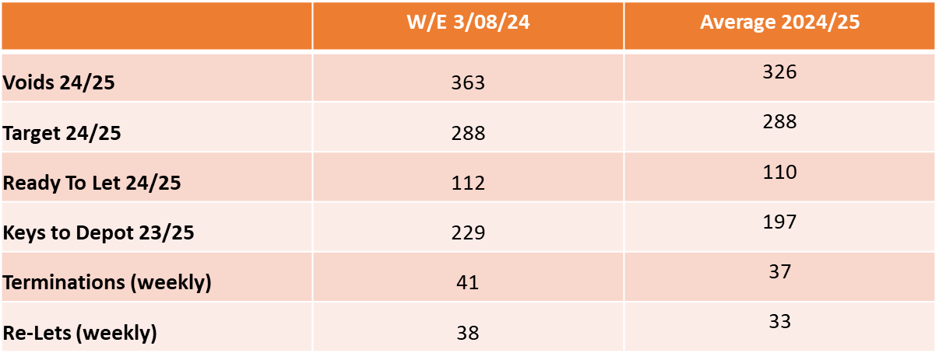

ZL explained we have 363 VOID properties in total, with 112 of them currently Ready to Let.

ZL provided members with some context to the volume of VOIDs her Empty Homes team deal with, explaining that in the last financial year, the team completed works on 1904 empty homes.

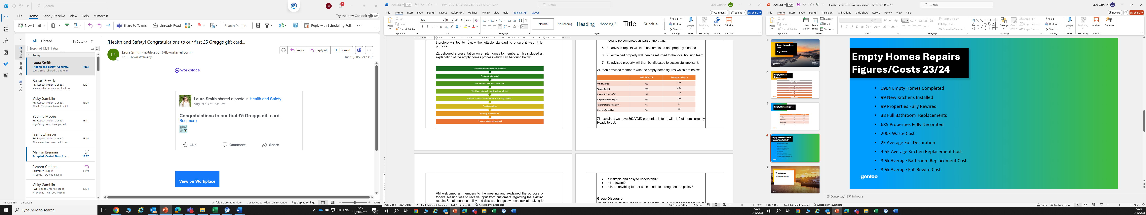

ZL advised the £200,000 waste cost is an area of concern, as this is customers rent which could be spent on improving VOID conditions, however, due to the items / condition some properties are left in, we are at times left with no option but to pay for this. ZL explained this cost does not cover labour etc therefore the figure will be a lot higher.

ZL advised there is a new piece of legislation called POPs. This means any upholstered furniture cannot be disposed of in general waste and we are required to pay £70 to dispose of each item. ZL advised this has come at a considerable cost to the business within the last 12 months.

ZL confirmed her team are trying to work smarter, as previously we would remove everything within an empty home, however, we will now leave carpets / flooring if they are in good condition and items of furniture if required. ZL advised they are going to start work with CSS furniture from 1 September to see if they can recycle any items on our behalf.

BN asked about chargeable repairs and if the inspectors who raise these are aware of the customers circumstances. ZL explained any chargeable repairs which are identified at the inspector’s assessment are passed to the Local Housing Team. Discussions will then be held between the Neighbourhood Co-ordinator and Neighbourhood Operations Manager as to if the customer will be charged. ZL confirmed the customers circumstances and reason for leaving will always be considered, so for example, if a customer left due to Domestic Violence, the likelihood is, the customer would not be charged. However, if a customer has left rubbish behind, and no arrangements were made for this removal, we would charge the customer.
 | - Visits to Empty Homes
LW requested members pick 4 properties from a list of empty homes. LW advised these properties would be at different stages of the VOID process. This would include:

- Keys which were recently returned from the customer.
- Keys which were recently returned from the empty homes team.

LW provided members with the Lettable Standard (appendix 1) as well as a VOID scorecard (appendix 2). It was requested that members rate the condition of each property and on return to the office, we would discuss findings.

Members collectively picked the following properties to visit:

Peacehaven Court Apartments (Returned from Empty Homes Team)
Baltimore Court (Returned from Empty Homes Team)
Sulgrave Road (Returned from Customer)
Trafalgar Road (Returned from Customer)
Rickleton Village Centre (Returned from Empty Homes Team)

Feedback from members below:

Peacehaven Court Apartments

Property was ready to let. Members agreed the property met a lettable standard and felt as though it was clean and tidy. Members did note the following concerns:

- Kitchen taps loose.
- Bedroom cupboard door faulty.
- Nail holes in hallway wallpaper
- Wallpaper removed from sitting room wall where fire surround used to be.
- Fan not working in bathroom. This is also not within the lettable standard. [1]

GW explained the incoming customer may have a decorative feature which they wish to add into the sitting room, and this could block the area where the wallpaper has been removed. GW explained if not, the Empty Homes Team would return and strip the rest of the wall. Members advised there needs to be a process where the incoming customer is informed of this [2]

GW explained the fan type was different in the bathroom, however has since confirmed to be working. GW confirmed other concerns would be resolved.

Baltimore Court

Property was ready to let. Members agreed the property met a lettable standard and was immaculate with a new bathroom / kitchen being installed as well as being fully decorated due to having a re-wire.

Members raised concerns with the DIY fence from next door, as this was leaning over the boundary line. As the neighbouring property is private, GW advised Local Housing Team would need to intervene and have conversation with occupier around this.

MS raised concerns about a radiator in bedroom which was installed on an angle. GW advised a job would be raised to rectify.

Sulgrave Road

Keys recently returned by customer, therefore works yet to start on the property. GW confirmed this will be a relatively short-term VOID with minimal work required

Tadcaster Road

Keys recently returned to area office, therefore works yet to start on the property. Property was in a state of disrepair with several rooms in an unacceptable condition. CS confirmed this may be a longer-term VOID due to works required.

Rickleton Village Centre

Property was ready to let. Members had the following concerns:

- Bare pipework throughout property (linking radiators to heating system) which had not been boxed in.
- Holes left in walls throughout.
- Flooring in kitchen was in poor condition.
- Wooden floor trims could be a tripping hazard.
- Some wallpaper removed / some not which would cause issues for incoming customer.
- Smoke alarms covered with plastic cladding.
- Flat was not clean.

 | - Feedback following Visits
LW took feedback from all customers following the visits. Members agreed they were impressed with the majority of those homes which were ready to let.

Discussion were held regarding the property at Rickleton Village Centre. GW & CS agreed with the member concerns surrounding the exposed pipework. They explained due to the concrete floors / ceilings, the pipework was left exposed to provide easy access in case of a leak. It was agreed to receive some clarity as to why we do not add trunking / boxing [3]

GW commented on the condition of the rest of the property and explained it was disappointing as would not be the level of standard he would expect. GW advised someone would return to the property to complete further works.

With regards to the kitchen floor, GW advised we do not provide floor coverings. GW acknowledged the floor was marked; however, this would have been cleaned while empty.

Members advised they would expect Gentoo to fill holes in walls etc while VOID, therefore asked if this would be an area we consider changing on the lettable standard [4]

CS advised members that any in-house decoration is completed with magnolia paint, this is because it takes less coats to cover. CS asked if members would prefer to see properties painted white. Members advised you could spend more painting a property white, just for the incoming customer to re-decorate, therefore the consensus was for us to continue using magnolia.

MS advised the lettable standard was quite brief and asked if this could be looked at. LW explained this would be looked as part of the next session.

 | Next Steps
 | LW confirmed there would be a further session as the deep dive does not end here. LW advised the lettable standard would be re-designed and will require customer input on this. LW also advised members that Gentoo want to ensure continuous feedback is received from customers regarding the condition of their new home, as we are not receiving regular feedback due to a lack of engagement from customers. We therefore want to create a new survey in which our involved customers design the questions.
 | Date of Next Session
 | Tuesday 17 September – 10:00am – 12:00pm– Emperor House Board Room

ACTION LOG
KEY
Action completion overdue
Action ongoing and date not due
Action required

ACTION REF | DETAILS | RESPONSIBILITY | TARGET COMPLETION | STATUS
27.08.24 [1] | Can we add extractor fans onto Lettable Standard document | Zoe Lambert | October 2024 | This has been added to the new lettable standard.
27.08.24 [2] | Need to create a process where Housing are kept informed of outstanding works, therefore they can keep incoming customer aware | Zoe Lambert | October 2024 | Email to be sent to Housing as part of process to make them aware of any outstanding issues, therefore they can keep customer informed as part of sign up.
27.08.24 [3] | Why do we not add trunking / boxing to horizontal pipework | Lewis Walmsley | October 2024 | This has never been within specification and no plans to change this.
27.08.24 [4] | Can we take ownership to fill in any holes, while property empty. | Zoe Lambert | October 2024 | Zoe to liaise with team to understand feasibility of this.

Appendix 1 – Gentoo’s Lettable Standard

Appendix 2 – Rate our Voids Scoresheet

