South’s Customer & Community Voice Meeting
held on Thursday 17 October 2024 10:00am – 12:00pm
at Akeler House Training Room
PRESENT |  | IN ATTENDANCE
David (DB)  Victoria (VS)  Jane (JS)  Phil (PH)  Vivienne (VD)  David (DW) |  | Lewis Walmsley (LW) – Customer Engagement Lead  Michael McGuigan (MM) – Customer Voice Manager  Russell Bewick (RB) – Neighbourhood Operations Manager
APOLOGIES
Doreen
Edith
Val
Liz
Denise
Michelle
PARA |  |  | ACTION
 | - Welcome and Apologies for Absence
 | DB welcomed those members who were in attendance and provided apologies for those who were unable to attend.
 | - Confirmation of Receipt and Review of Minutes
 | DB confirmed all had received minutes prior to the meeting and no issues were raised.
 | - CHAIRs Meeting Update
DB advised he attended the CHAIRs Meeting in September and raised concerns regarding the limited attendance and lack of agenda items coming from customers. DB re-iterated to those in attendance that these meetings are designed for customers to talk about the issues which are important to them.

DB advised concerns about the parking at Lakeside were raised. LW provided an update, explaining land around Lakeside is currently split between Sunderland City Council / Gentoo and costs to re-develop land would be significant. LW advised Gentoo have previously reviewed this alongside SCC, however at this moment in time, there’s no intention to increase parking capacity.

DB discussed drop-in sessions and how the group held these on an afternoon / evening. LW explained they were not well attended, as we did not have any customers in attendance. LW advised they will persist with these and change the locations as it could have been the areas chosen which meant customers were not in attendance. LW advised it is important we continue to reach out to communities to hear from seldom-heard customers.
It was agreed the information from the CCV’s need to feed into the Customer Committee and vice versa. VS explained she was attending today, as wanted to gain an understanding as to what the CCV’s were about.

DB advised the group received their regulatory judgement in which they were awarded C1 (Consumer) / V2 (Viability) / G1 (Governance). Further information on what this means can be found on the link below:

https://www.gentoogroup.com/news/2024/august/we-have-achieved-the-highest-rating-for-regulator-s-consumer-standards/

DB explained members of Customer Committee had attended the Housing Summit. MM advised they were only 1 of 2 organisations who brought customers to the conference. MM advised complaints talk and panel discussion highlighted best practice when it comes to complaints. MM advised it was re-assuring to know Gentoo had already implemented some of the recommendations.
 | Customer Committee
DB raised concerns regarding a lack of visibility at Customer Committee and how the Customer & Community Voice Groups do not get to hear what is going on. MM explained visibility will be provided at all CCV meetings going forward. It was recommended a member of Customer Committee attends all CCV ‘s going forward to provide an update back to its members.

VS explained she attends Customer Committee and does not want there to be a divide between the two groups. VS felt as though there was a stigma attached to committee members, when in fact they are just customers and just want to hold the group to account, to ensure the best possible service is being provided.

 | Housing Update
RB introduced himself as one of the Neighbourhood Operations Managers within the South area. He explained the South area was split into 27 different patches, with 14 NC’s managing Tenancy & Estate and 10 NC’s managing income. RB advised following the meeting, a full T&E update will be provided so customers can understand the issues Gentoo experience within estates. [1]

Members raised concerns around ASB and what the group can do when it comes to Noise Nuisance. RB advised we use the Noise App where customers can record the level of noise being made, they would then submit the recordings into the Group for a colleague to review. RB encouraged any issues of ASB need to be reported to their NC.

PH advised they sometime do not know who the NC is because they change that often. PH asked if a message can be sent to his street advising who the NC is, and their contact details be provided. LW explained this would be picked up as an action. [2]

PH asked if when an NC leaves, does the mobile number automatically transfer to the incoming NC, advised I was unaware, however would find out. [3]

PH asked when the Grass Cutting stops for the year. LW advised it will have likely already stopped. LW advised he would check the website for further information. [4]

https://www.gentoogroup.com/your-neighbourhood/maintaining-the-land-around-your-home/

 | Engagement Update
DB advised an engagement update was provided as part of the CHAIR’s meeting as the group push to create a strategy. DB advised a maturity model was presented, which can be found below.

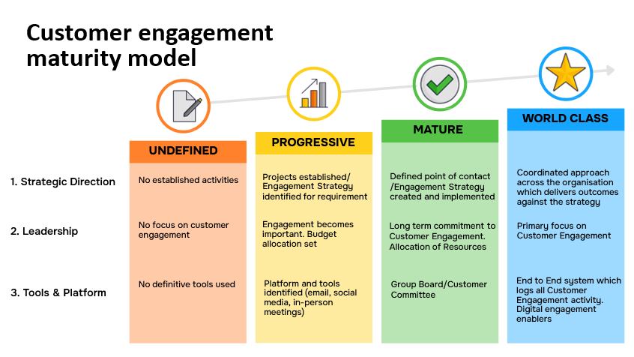

DB advised it was agreed that we were currently between ‘progressive’ and ‘mature’

MM advised we will be commissioning TPAS to complete some work to help us with our engagement model.
 | - Review Design of New ASPIRE Application / Guidance
LW provided members with the new ASPIRE application / guidance and requested feedback. Members felt as though the information was easy to follow and the design was much improved. LW explained they will use this going forward. LW advised a new centralised panel was going to be set up to decide ASPIRE applications, this was to give customers more accountability in the decision-making process. LW advised a date would be set for November to complete a trail run.

The application / guidance can be found below.
 | Any Other Business
VD explained she is experiencing issues with a tree root near her property. Advised this would be passed to the NC. [5]

Members were interested in the work the Box Youth Project do and advised it might be useful to hear from them as part of the next meeting. [6]
 | - Dates of Next Meeting
Akeler House

Centralised Christmas CCV Meeting - Tuesday 10 December 2024 - Akeler House – 3pm – 5pm

Friday 7 February 2025 – 10am – 12pm
Friday 9 May 2025 – 10am – 2pm
Friday 8 August 2025 – 10am – 12pm
Friday 7 November 2025 – 10am – 12pm

ACTION LOG
KEY
Action completion overdue
Action ongoing and date not due
Action required

ACTION REF | DETAILS | RESPONSIBILITY | TARGET COMPLETION | STATUS
17.10.24 [1] | T&E Update to be provided to all members | Lewis Walmsley | 01.11.24 | Provided as part of minutes.
17.10.24 [2] | Send SMS to Shawdon Close providing details of the Neighbourhood Co-ordinators | Lewis Walmsley | 01.11.24 | Text message sent to customers notifying them of NC for area.
17.10.24 [3] | Do work mobiles automatically change from the old NC to the new NC | Lewis Walmsley | 01.11.24 | This is being reviewed.
17.10.24 [4] | When does the Grass Cutting season finish | Lewis Walmsley | 01.11.24 | Information provided on the link within the minutes.
27.10.24 [5] | Issue with tree coming through path at Newtonmore | Grounds Maintenance | 01.11.24 | Requested Grounds Maintenance contact VD to further discuss.
27.10.24 [6] | Could Box Youth Project attend next CCV meeting | Lewis Walmsley | 01.11.24 | To link in with Box Youth within 2025

