Empty Homes Deep Dive – Central
held on Wednesday 14 August 2024 – 9:00am – 15:00pm
at City Hall – Gentoo Office
PRESENT |  | IN ATTENDANCE
John (JM)  David (DW)  Michelle (MW)  Brenda (BS)  Lucky (LP)  James (JL) |  | Lewis Walmsley (LW) – Customer Engagement Lead  Michael McGuigan (MM) – Customer Voice Manager  Zoe Lambert (ZL) – Operations Manager (Empty Homes)  Gareth Wynn (GW) – Repairs & Maintenance Manager - VOIDs  Mark Robson (MR) – Repairs & Maintenance Manager - VOIDs
PARA |  |  | ACTION
 | - Introduction – Empty Homes Deep Dive
LW provided a round of introductions with all colleagues explaining their role within the organisation.

LW explained the purpose of todays session was to provide customers with the opportunity to scrutinise our empty homes and provide recommendations for improvement. LW advised members that the group have experienced a recent increase in complaints from those customers who have just moved in, therefore wanted to review the lettable standard to ensure it was fit for purpose.

ZL delivered a presentation on empty homes to members. This included an explanation of the empty homes process which can be found below:

- ZL explained all customers are required to provide a 28-day notice period (as per tenancy agreement) however, this does not apply to those customers who are moving from one Gentoo property too another.

- ZL advised the NC will then complete a pre-termination visit with the outgoing customer. This is to ensure there have been no unauthorised alterations or damage to the property. ZL advised any concerns identified would either warrant a chargeable repair, or the customer reverting any alterations back to the original condition. ZL acknowledged some customers will not allow us into their home and therefore, we are unable to complete an inspection until the keys have been returned.

ZL explained in the instances where a customer is transferring from one Gentoo property too another, we will follow the same process and any issues may prevent a move from going ahead.

- ZL advised a mutually agreed date will be arranged with the customer to collect keys and complete a final check of the property. If actions have not been completed as agreed at the pre-termination visit, the customer may be informed chargeable repairs will be raised.

- ZL explained once the keys are received, the Empty Property Officer will complete an inspection of the property and identify works which need to be completed as part of the VOID.

- ZL advised repairs will then be completed and property cleaned.

- ZL explained property will then be returned to the local housing team.

- ZL advised property will then be allocated to successful applicant.

ZL then provided members with the empty home figures which are below:

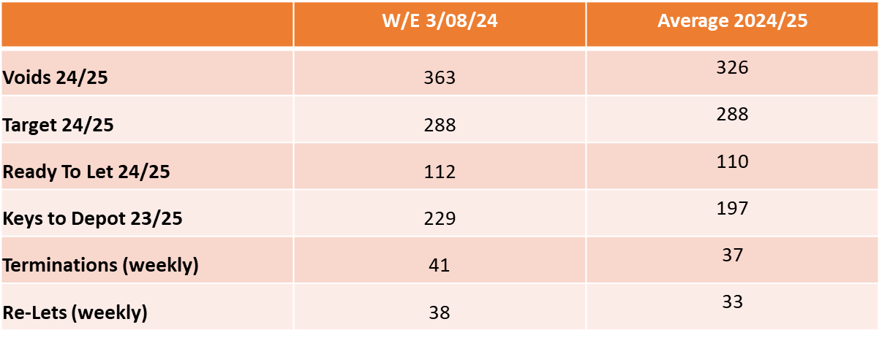

ZL explained we have 363 VOID properties in total, with 112 of them currently Ready to Let. ZL advised this figure changes daily.

ZL provided members with some context to the volume of VOIDs her Empty Homes team deal with, explaining that in the last financial year, the team completed works on 1904 empty homes.

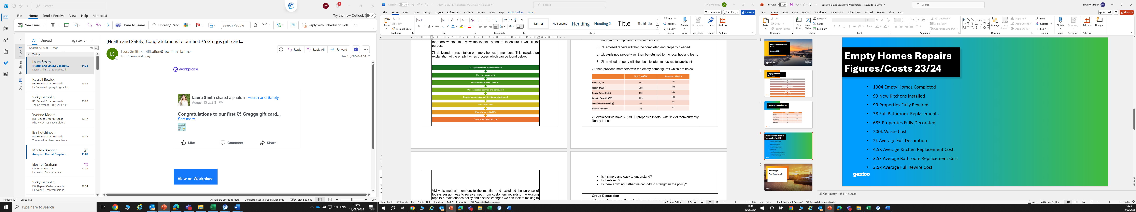

ZL advised the £200,000 waste cost is an area of concern, as this is customers rent which could be spent on improving VOID conditions, however, due to the items / condition some properties are left in, we are at times left with no option but to pay for this.

ZL advised there is a new piece of legislation called POPs. This means any upholstered furniture cannot be disposed of in general waste and we are required to pay £70 to dispose of each item. ZL advised this has come at a considerable cost to the business within the last 12 months.

ZL provided members with an example of a property recently received from Hendon Close. ZL explained the property had been vandalised and the Empty Homes Team would incur significant costs to ensure the property meets a lettable standard. A photo is provided below for reference.

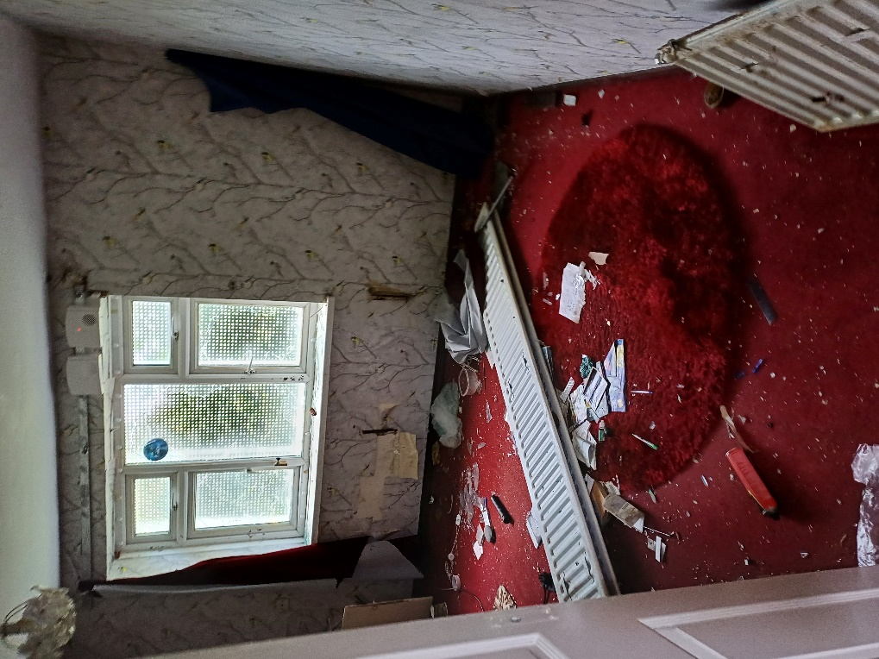

ZL confirmed her team are trying to work smarter, as previously we would remove everything within an empty home, however, we will now leave carpets / flooring if they are in good condition and items of furniture if required.

ZL advised they are going to start work with CSS furniture from 1 September to see if they can recycle items on our behalf. More information on the service can be found below.

https://www.csshelp.org/furniture-service

ZL asked members if there were any questions / queries following the presentation.

MW queried if there was debt on the meter left by the previous customer, who would be responsible for this. ZL explained the amounts are normally nominal, therefore we contact the relevant supplier and clear the outstanding amount.

JM asked if a property was to become empty in one of the sheltered schemes, would the same process be followed. ZL confirmed this was accurate and it would be treated the same as an empty home.

JM asked if hooks etc can be left in the walls, as taking out requires redecorating and customer may be unable to do this. ZL advised it could be looked into. [1]

 | - Visits to Empty Homes
LW requested members pick 4 properties from a list of empty homes. LW advised these properties would be at different stages of the VOID process. This would include:

- Keys which were recently returned from the customer.
- Keys which were recently returned from the empty homes team.

LW provided members with the Lettable Standard (appendix 1) as well as a VOID scorecard (appendix 2). It was requested that members rate the condition of each property and on return to the office, we would discuss findings.

Members collectively picked the following properties to visit:

Westheath Avenue (Returned from Customer)
Wayland Square (Returned from Empty Homes Team)
Nicholson Close (Returned from Empty Homes Team)
Halidon Road (Returned from Empty Homes Team)
Heworth Court (Returned from Empty Homes Team)

Feedback from members below:

Westheath Avenue

- Keys to property were recently received from customer. Members raised concerns regarding damp and mould throughout the property which ZL recognised would need to be addressed. Works would be required throughout to ensure property was ready to let.

Wayland Square

- Property was ready to let. Members commented a customer moving into the property would need to re-decorate, however recognised this would be their responsibility. Fitted wardrobes in situ which members felt was a real positive.

Nicholson Close

- Property was ready to let. All agreed the property met a lettable standard.

JM advised the gardens were unkept and required some attention. ZL advised the Grounds Maintenance Team would attend and address this, however this may occur once a customer has moved in. All agreed the condition would not prevent a customer from moving in.

Halidon Road

- Property was ready to let. All members agreed the property met a lettable standard. Members commented that the flat was well presented however gardens required attention. ZL advised Grounds Maintenance would follow this up.

Heworth Court

- Property was ready to let. All agreed the property met a lettable standard with some decoration required, which would be a customer responsibility. Members commented the flat was clean and tidy.

 | - Feedback following Visits
LW took feedback from all customers following the visits. All members agreed they were impressed with the property condition of those homes which were ready to let.

JM asked if the group could consider a handyman service to support customers who may require decorating as there will be a large proportion of customers who cannot complete this. Members advised there are external agencies out there as Sunderland Care & Support offer a handyperson service who can complete smaller jobs for those customers who may struggle to complete works. ZL advised if Housing identify a customer who may require the property decorating, she will ask her team to support. ZL advised it would be beneficial if Housing could link in closer with her teams to identify cases like this. [2]

JL asked if the group could consider adding a question on the housing application, asking customer if they would require any support when moving in. ZL acknowledged this would be a good idea [3]
 | Next Steps
LW & ZL confirmed they had a further 3 sessions they were running across the City to seek further feedback and to ensure there is a consistency in the service in which the EH team deliver.

LW confirmed there would be a further session as the deep dive does not end here. LW advised the lettable standard would be re-designed and will require customer input on this. LW also advised members that Gentoo want to ensure continuous feedback is received from customers regarding the condition of their new home, as we are not receiving regular feedback due to a lack of engagement from customers. We therefore want to create a new survey in which our involved customers design the questions.
 | Date of Next Session
 | Tuesday 17 September – 10:00am – 12:00pm – Emperor House Board Room

ACTION LOG
KEY
Action completion overdue
Action ongoing and date not due
Action completed

ACTION REF | DETAILS | RESPONSIBILITY | TARGET COMPLETION | STATUS
14.08.24 [1] | Can we leave hooks in walls to prevent customers from having to re-decorate? | Zoe Lambert | 14.09.24 | This is not a process that will be changed as customers who move in, tend to remove these and can cause further damage.
14.08.24 [2] | Can the Housing and Empty Homes Team link in closer to identify customers who may require support | Zoe Lambert / Lynn Park | 14.09.24 | There is open communication between the two teams ensuring the incoming customer has the support required.
14.08.24 [3] | Can we add a question on Housing applications asking customers what type of support they may require when moving into a property. | Lynn Park | 14.09.24 | There is now a question within the application regarding this.

Appendix 1 – Gentoo’s Lettable Standard

Appendix 2 – Rate our Voids Scoresheet

