Empty Homes Deep Dive – South
held on Monday 12 August 2024 – 9:00am – 15:00pm
at Akeler House Training Room
PRESENT |  | IN ATTENDANCE
Doreen (DR)  David (DB)  Samantha (SJ)  Phillip (PH)  Jane (JS) |  | Lewis Walmsley (LW) – Customer Engagement Lead  Zoe Lambert (ZL) – Operations Manager (Empty Homes)  Gareth Wynn (GW) – Repairs & Maintenance Manager - VOIDs  Mark Robson (MR) – Repairs & Maintenance Manager - VOIDs
PARA |  |  | ACTION
 | - Introduction – Empty Homes Deep Dive
LW provided a round of introductions with all colleagues explaining their role within the organisation.

LW explained the purpose of todays session was to provide customers with the opportunity to scrutinise our empty homes and provide recommendations for improvement. LW advised members that the group have experienced a recent increase in complaints from those customers who have just moved in, therefore wanted to review the lettable standard to ensure it was fit for purpose.

ZL delivered a presentation on empty homes to members. This included an explanation of the empty homes process which can be found below:

- ZL explained all customers are required to provide a 28-day notice period (as per tenancy agreement) however, this does not apply to those customers who are moving from one Gentoo property too another.

- ZL advised the NC will then complete a pre-termination visit with the outgoing customer. This is to ensure there have been no unauthorised alterations or damage to the property. ZL advised any concerns identified would either warrant a chargeable repair, or the customer reverting any alterations back to the original condition. ZL acknowledged some customers will not allow us into their home and therefore, we are unable to complete an inspection until the keys have been returned.

ZL explained in the instances where a customer is transferring from one Gentoo property too another, we will follow the same process and any issues may prevent a move from going ahead.

- ZL advised a mutually agreed date will be arranged with the customer to collect keys and complete a final check of the property. If actions have not been completed as agreed at the pre-termination visit, the customer may be informed chargeable repairs will be raised.

- ZL explained once the keys are received, the Empty Property Officer will complete an inspection of the property and identify works which need to be completed as part of the VOID.

- ZL advised repairs will then be completed and property cleaned.

- ZL explained property will then be returned to the local housing team.

- ZL advised property will then be allocated to successful applicant.

ZL then provided members with the empty home figures which are below:

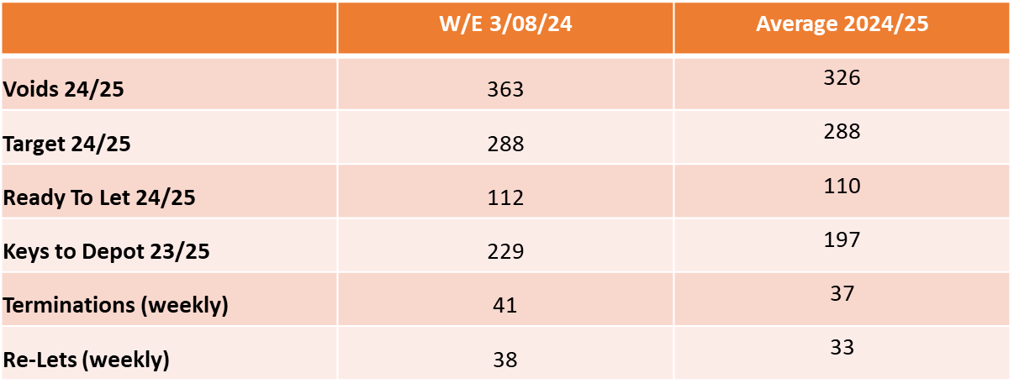

ZL explained we have 363 VOID properties in total, with 112 of them currently Ready to Let. ZL advised this figure changes daily.

ZL provided members with some context to the volume of VOIDs her Empty Homes team deal with, explaining that in the last financial year, the team completed works on 1904 empty homes.

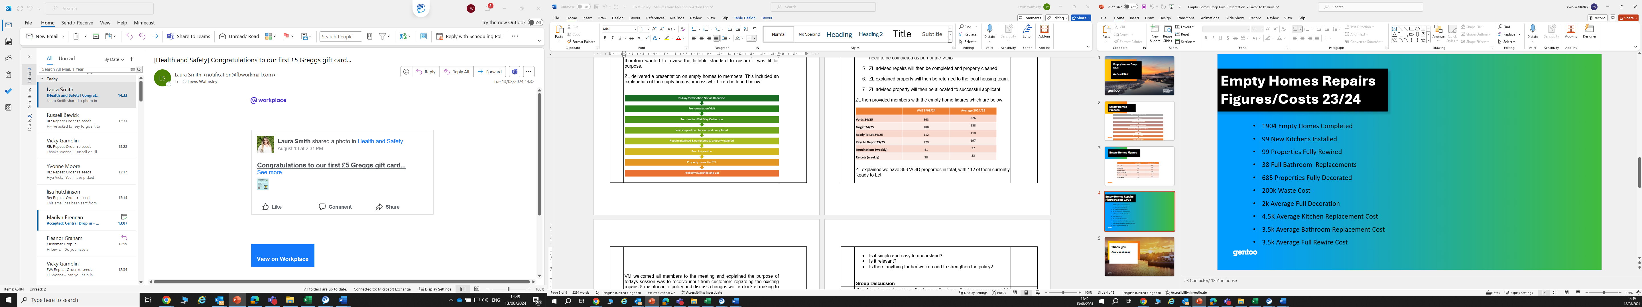

ZL advised the £200,000 waste cost is an area of concern, as this is customers rent which could be spent on improving VOID conditions, however, due to the items / condition some properties are left in, we are at times left with no option but to pay for this.

DR advised the waste cost was an area of concern and asked if leaving the property clean and empty can be written into a customers tenancy agreement. LW & ZL explained this is already within the customer handbook, which is provided to all customers at sign up. LW explained we would not allow a customer to transfer homes if they have left a property in bad condition, however acknowledged it is difficult to recoup waste costs from customers who are leaving Gentoo to move elsewhere. ZL advised we would leave a charge on the account, therefore, if they were ever to try and return to a Gentoo property, they would be required to clear the full balance.

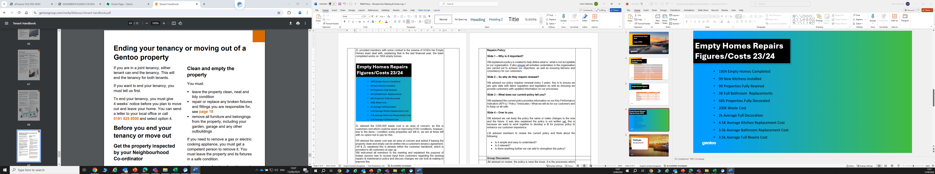

SJ raised concerns that when she came to move out of her previous property, Gentoo tried to charge her for alterations that were completed by a previous customer who had lived at the property. ZL explained that as part of the VOID inspection, photos will be taken of the property, therefore, if customers want to dispute a certain aspect of the property, we will have evidence of the overall condition.

ZL confirmed her team are trying to work smarter, as previously all items would be removed within an empty home, however, we will now leave carpets / flooring if they are in good condition and items of furniture if required.

DR asked if the team currently look to re-supply TV’s / Cupboards / Sofa’s / Furniture to other customers who would benefit from this. ZL confirmed they do not at present, as they simply do not have the resource or storage to do this. ZL confirmed this is an area she is currently reviewing, as discussions are being held with a supplier to review if they can do this on our behalf. DR recommended this as an area of improvement. [1]

SJ asked if Gentoo could consider storing and selling items to other customers who would benefit from this. ZL advised this would not be ruled out, however would require considerable resource, which at present the group does not have.

 | - Visits to Empty Homes
LW requested members pick 4 properties from a list of empty homes. LW advised these properties would be at different stages of the VOID process. This would include:

- Keys which were recently returned from the customer.
- Keys which were recently returned from the empty homes team.

LW provided members with the Lettable Standard (appendix 1) as well as a VOID scorecard (appendix 2). It was requested that members check the property condition against the lettable standard and once returned to the office, we would discuss findings.

Members collectively picked the following properties to visit:

Gillingham Road (Returned from Customer)
Australia Tower (Returned from Empty Homes Team)
Courtney Drive (Returned from Empty Homes Team)
Wilkinson Terrace (Returned from Customer)
Avonmouth Road (Returned from Empty Homes Team)

Photos at each address were taken (appendix 3) and the following outcomes were documented:

Gillingham Road

- Keys were recently handed back from the customer, therefore works yet to start on the 2-bedroom flat. Members were shocked at the condition the property had been left in by the previous customer. Whilst property did not meet the lettable standard, there was a plausible explanation for this.

Australia Tower

- Property was ready to let, there were no concerns regarding the condition raised by members. All agreed this met a lettable standard.

Courtney Drive

- Property was ready to let. All agreed the property met a lettable standard however there were some queries:

DR asked if the skirtingboards should be painted, as was under the impression this was Gentoo’s responsibility from conversations she has previously had with colleagues. ZL advised this is not an area which the VOID team would be responsible for, as customers are responsible for woodwork as per lettable standard. DR recommended this is an area for consideration [2]

DR also raised concerns with the kitchen door, explaining the strip had not been fully painted. DR recommended the EH (Empty Homes) Team should pick this up. ZL advised the customer would normally be responsible for this as it would be classed as decorative. Regardless, it would be an area for consideration [2]

Members advised gardens required maintenance. GW explained the gardens would receive a cut via our Grounds Maintenance Team, however, this may occur once a customer has moved in. Members agreed this was acceptable as the garden condition would not prevent a customer from moving in.

Members advised the plastering around the bedroom light could have received a better finish and questions were asked if the customer should be expected to rectify this. Members advised if this was their home, a repair request would likely be raised causing an unnecessary return for the repair team. Members also advised that as the property type was a bungalow, expectation is elderly or disabled customers may move in who do not have support to complete ceiling works. ZL & GW agreed a better finish could have been provided in this scenario.

JS & PH advised a small bit of plastering needed adding around the sitting room window.

SJ advised there was rubbish behind the radiators.

Wilkinson Terrace

- Keys were recently handed back from customer. Works were yet to start by the EH team. Members were again surprised at the number of items left by the previous customer. It was agreed works were required to bring the property to a lettable standard, however this would be picked up by EH team.

Avonmouth Road

- Property was ready to let. All agreed the property met a lettable standard with some decoration required, which would be a customer responsibility.

 | - Feedback from Visits
LW took feedback from all customers following the visits. All members agreed they were impressed with the property condition of those homes which were ready to let.

PH asked on the pre-inspection sheet completed by the Neighbourhood Co-ordinators, if there is a question asked regarding the carpet / flooring remaining or not remaining in situ. LW advised he was unsure, however would investigate this. LW confirmed if it was not, he would look to see if this could be added. [3]

LW asked members if there was one improvement that could be made to the lettable standard, what would this be? Members advised the current standard was thorough and had nothing further to add.

 | Next Steps
LW & ZL confirmed they had a further 4 sessions they were running across the City to seek further feedback and to ensure there is a consistency in the service in which the EH team deliver.

LW confirmed there would be a further session as the deep dive does not end here. LW advised the lettable standard would be re-designed and will require customer input on this. LW also advised members that Gentoo want to ensure continuous feedback is received from customers regarding the condition of their new home, as we are not receiving regular feedback due to a lack of engagement from customers. We therefore want to create a new survey in which our involved customers design the questions.
 | Date of Next Session
 | Tuesday 17 September – 10:00am – 12:00pm – Emperor House Board Room

ACTION LOG
KEY
Action completion overdue
Action ongoing and date not due
Action required

ACTION REF | DETAILS | RESPONSIBILITY | TARGET COMPLETION | STATUS
12.08.24 [1] | Can we ensure items which are left in properties by customers, in a reasonable condition, can be reused by those most in need. | Zoe Lambert | October 2024 | Gentoo have created a partnership with CSS furniture from 1 September. They will remove suitable furnishings from our properties across Sunderland and re-sell these to low-income households across the City. More information on their services can be found below.  https://www.csshelp.org/furniture-service
12.08.24 [2] | Would we consider painting woodwork (skirtingboards / internal doors) as part of the lettable standard. | Zoe Lambert | October 2024 | We would judge this as a customer responsibility, therefore would not add this into the lettable standard.
12.08.24 [3] | Can we add a question on the pre-inspection sheet regarding flooring / carpets being left. | Lynn Park | October 2024 | This will be documented as part of the process

Appendix 1 – Gentoo’s Lettable Standard

Appendix 2 – Rate our Voids Scoresheet

Appendix 3 – Photos from South’s Empty Homes Deep Dive

