Empty Homes Deep Dive – Houghton & Hetton
held on Thursday 22 August 2024 – 9:00am – 15:00pm
at Skyline Training Room
PRESENT |  | IN ATTENDANCE
Julia (JW)  Evelyn (EC)  Pam (PC)  Karen (KC) |  | Lewis Walmsley (LW) – Customer Engagement Lead  Zoe Lambert (ZL) – Operations Manager (Empty Homes)  Gareth Wynn (GW) – Repairs & Maintenance Manager - VOIDs
PARA |  |  | ACTION
 | - Introduction – Empty Homes Deep Dive
LW provided a round of introductions with all colleagues explaining their role within the organisation.

LW explained the purpose of todays session was to provide customers with the opportunity to scrutinise our empty homes and provide recommendations for improvement. LW advised members that the group have experienced a recent increase in complaints from those customers who have just moved in, therefore wanted to review the lettable standard to ensure it was fit for purpose.

ZL delivered a presentation on empty homes to members. This included an explanation of the empty homes process which can be found below:

- ZL explained all customers are required to provide a 28-day notice period (as per tenancy agreement) however, this does not apply to those customers who are moving from one Gentoo property too another.

- ZL advised the NC will then complete a pre-termination visit with the outgoing customer. This is to ensure there have been no unauthorised alterations or damage to the property. ZL advised any concerns identified would either warrant a chargeable repair, or the customer reverting any alterations back to the original condition. ZL acknowledged some customers will not allow us into their home and therefore, we are unable to complete an inspection until the keys have been returned.

ZL explained in the instances where a customer is transferring from one Gentoo property too another, we will follow the same process and any issues may prevent a move from going ahead.

- ZL advised a mutually agreed date will be arranged with the customer to collect keys and complete a final check of the property. If actions have not been completed as agreed at the pre-termination visit, the customer may be informed chargeable repairs will be raised.

- ZL explained once the keys are received, the Empty Property Officer will complete an inspection of the property and identify works which need to be completed as part of the VOID.

- ZL advised repairs will then be completed and property cleaned.

- ZL explained property will then be returned to the local housing team.

- ZL advised property will then be allocated to successful applicant.

ZL then provided members with the empty home figures which are below:

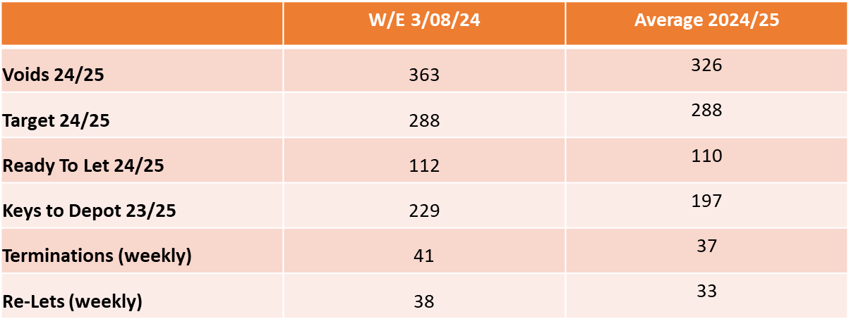

ZL explained we have 363 VOID properties in total, with 112 of them currently Ready to Let. ZL advised the figure changes daily.

ZL provided members with some context to the volume of VOIDs her Empty Homes team deal with, explaining that in the last financial year, the team completed works on 1904 empty homes.

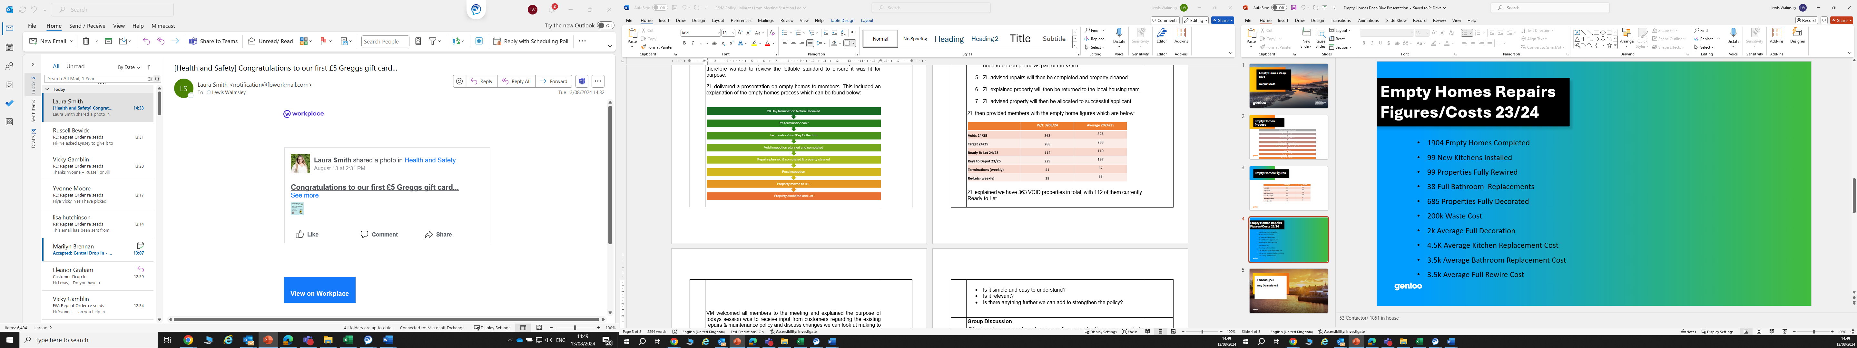

ZL advised the £200,000 waste cost is an area of concern, as this is customers rent which could be spent on improving VOID conditions, however, due to the items / condition some properties are left in, we are at times left with no option but to pay for this. ZL explained this cost does not cover labour etc therefore the figure will be a lot higher.

ZL advised there is a new piece of legislation called POPs. This means any upholstered furniture cannot be disposed of in general waste and we are required to pay £70 to dispose of each item. ZL advised this has come at a considerable cost to the business within the last 12 months.

ZL confirmed her team are trying to work smarter, as previously we would remove everything within an empty home, however, we will now leave carpets / flooring if they are in good condition and items of furniture if required. ZL advised they are going to start work with CSS furniture from 1 September to see if they can recycle any items on our behalf.

KC asked if Gentoo could look at setting up their own recycling centre. ZL advised it has been considered, however there is not the resource within the team to currently facilitate this.
 | - Visits to Empty Homes
LW requested members pick 4 properties from a list of empty homes. LW advised these properties would be at different stages of the VOID process. This would include:

- Keys which were recently returned from the customer.
- Keys which were recently returned from the empty homes team.

LW provided members with the Lettable Standard (appendix 1) as well as a VOID scorecard (appendix 2). It was requested that members rate the condition of each property and on return to the office, we would discuss findings.

Photos taken from visits can be found on (appendix 3).

Members collectively picked the following properties to visit:

Ferndale Road (Returned from Customer)
The Haven (Returned from Empty Homes Team)
The Anchorage (Returned from Empty Homes Team)
Morris Terrace (Returned from Empty Homes Team)
Queensway (Returned from Empty Homes Team)

Feedback from members below:

Ferndale Road

Keys had just been returned from customer, therefore no works had yet to be completed. Members were surprised at the property condition with it being unkept throughout. GW explained the property would require a full re-wire as well as a new kitchen. Property would also need a deep clean as well as a decoration pack throughout. GW advised the property would be a long-term VOID and the financial cost would be upwards of £20,000 to put the property back to a lettable standard.

The Haven

Property was ready to let. Members agreed the property met a lettable standard. KC raised concerns regarding limescale around the taps and a leak from the toilet. JW commented the carpets were well presented

The Anchorage

Property was ready to let. Members agreed the property met a lettable standard and just required decorating by incoming customer.

Morris Terrace

Property was ready to let. All members agreed the property met a lettable standard. Members again commented on limescale around taps. Members felt the property offered good storage as well as having carpets on stairs and bedroom.

Queensway

Property was ready to let. Members agreed the property was ready to let, however there were some concerns. Externally there was a downpipe and the drain had no cover. Holes in the rendering also made the property look quite tired from the outside not giving members a good first impression. Members also noted a cracked step in the garden to the rear as well as limescale on the taps in the sink / bath. GW advised jobs would be raised regarding all concerns. All agreed works would not prevent a customer from moving in.

 | - Feedback following Visits
LW took feedback from all customers following the visits. All members agreed they were impressed with the property condition of those homes which were ready to let.

Members agreed that recycling needs to be looked at more seriously as one of the properties had several items which appeared to be brand new, however as the group did have the means to store these, they would have to be disposed of. Members advised in current crisis this was not acceptable. ZL discussed that the partnership with CSS should mean this does not continue to happen, however this will need to be reviewed. ZL agreed that alternate partnerships could still be explored. [1]

Members mentioned there were several properties with limescale around the taps and this was a theme throughout the visits. GW explained depending on the severity, there are several options. Either the taps are removed and replaced, or the cleaners / plumbers remove the limescale. GW advised this would be an action he picks up with the wider teams. To consider if this can be added within the lettable standard. [2]

KC asked if the group could look at setting up a volunteer service, where individuals could work with the group to re-decorate empty properties, as well as completing works to gardens etc. KC explained this could help individuals get into work as well as helping the group turn around properties quicker. LW advised the suggestion was valid and to review feasibility of this with Empty Homes team. [3]

Members were advised that we currently decorate properties (where necessary) with magnolia paint. This is to provide customers with a base coat. Members were asked their views on this. Members advised a white coat would make the house feel fresher than using magnolia, however understood that using white paint would be more time consuming (as more coats may be required).

Members were asked about the information within the lettable standard. Members agreed they were happy with the content that was included.

 | Next Steps
LW & ZL confirmed they had one more session they were running to seek further feedback and to ensure there is a consistency in the service in which the EH team deliver.

LW confirmed there would be a further session as the deep dive does not end here. LW advised the lettable standard would be re-designed and will require customer input on this. LW also advised members that Gentoo want to ensure continuous feedback is received from customers regarding the condition of their new home, as we are not receiving regular feedback due to a lack of engagement from customers. We therefore want to create a new survey in which our involved customers design the questions.
 | Date of Next Session
 | Tuesday 17 September – 10:00am – 12:00pm – Emperor House Board Room

ACTION LOG
KEY
Action completion overdue
Action ongoing and date not due
Action required

ACTION REF | DETAILS | RESPONSIBILITY | TARGET COMPLETION | STATUS
22.08.24 [1] | Can we explore alternative partnerships when it comes to Recycling? | Zoe Lambert | October 2024 | Ongoing action for Zoe and her team as acknowledged this is an area for improvement.
22.08.24 [2] | Can we consider adding a section on limescale within the lettable standard? | Zoe Lambert | October 2024 | Section added within the new lettable standard regarding this.
22.08.24 [3] | Can we explore the possibility of a volunteer service for customers? | Zoe Lambert | October 2024 | This is currently not feasible for the organisation, therefore we are unable to commit to this.

Appendix 1 – Gentoo’s Lettable Standard

Appendix 2 – Rate our Voids Scoresheet

